**NAME: TAZAIM AMIR ENROLLMENT: 02-131202-075**

**SYSTEM PROGRAMMING OEL**

**TASK:1**

#include<iostream>

#include<direct.h>

#include<conio.h>

#include<process.h>

#include<stdio.h>

#include<string>

#include<fstream>

using namespace std;

int main() {

if (_mkdir("C:\Oel\Loggedin_User + today date") == -1)

cout << "File Not Created";

else

cout << "File Created";

}

ofstream MyFile("C:\Oel\Loggedin_User + today date\\file1.txt");

if (MyFile) {

}

else {

cout << "File NOT Created";

}

MyFile.close();

string line;

ifstream in_file{ "C:\Oel\Loggedin_User + today date\\file1.txt" };

ofstream out_file{ "C:\Oel\Loggedin_User + today date\\file1.txt" };

if (in_file && out_file) {

while (getline(in_file, line)) {

out_file << line << "\n";

}

cout<<"Copying File is Done\n";

}

else {

printf("Cannot Read File");

}

in_file.close();

out_file.close();

return 0;

ofstream MyFile("C:\Oel\Loggedin_User + today date\\file1.txt");

cout << "Data of File 1 is Deleted";

}

**OUTPUT:**

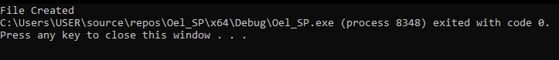

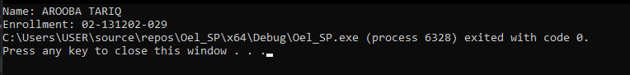

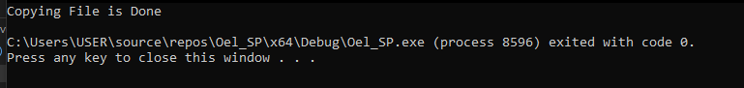

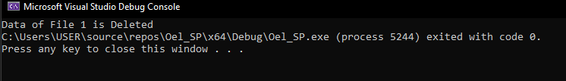

**TASK:2**

void Inner()

{

throw string("Hey My name is Tazaim Amir");

}

void Outer()

{

try

{

Inner();

}

catch (string excep)

{

cout << "Outer caught an exception: ";

cout << excep << endl;

throw;

}

}

int main() {

try

{

Outer();

}

catch (string excep)

{

cout << "Main caught an exception: ";

cout << excep << endl;

}

return 0;

}

**OUTPUT:**



**TASK:3**

void fnTaxCalculation()

{

const double tax_rate1 = 0.15;

const double tax_rate2 = 0.25;

double tax = 0;

double trans_fee = 20;

double int_trans = 0;

cout << "Enter the Trannsferred Amount: ";

cin >> int_trans;

cout << "\nTotal Tax Applied on an Amount is : ";

if (int_trans <= 10000) {

tax = tax_rate1 * int_trans;

}

else {

tax = tax_rate2 * int_trans;

}

tax += trans_fee;

cout << tax;

}

#include"tax_calc.h"

#include <iostream>

using namespace std;

int main()

{

double funds = 0;

double fund = 3770;

cout << "Enter the funds:";

cin >> funds;

cout << "\ntotal tax amount deducted will be:";

cout << fund;

tax_calc::international_transfer::calc(fund);

return 0;

}

**OUTPUT:**

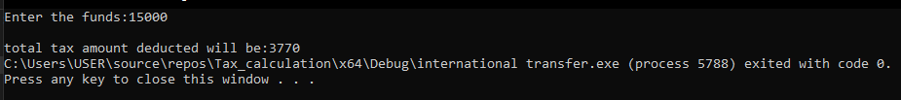

**TASK:4**

#include<stdio.h>

#include<sys/types.h>

#include<unistd.h>

int main()

{

pid_t pid;

pid = fork();

if (pid == 0)

{

printf("I am child and my parent is %d and my own PID is %d\n", getppid(), getpid());

}

else if (pid > 0)

{

printf("I am a Parent and my pid is %d\n", getpid());

}

return 0;

}

**OUTPUT:**

